# NEPR 2017-07: Bend Test Protocols

## 3-Point Bend Test Settings *NEPR 2017-07* *Longer Travel*

For testing the bending strength of CCX according to ASTM WK49719. Test MD first then TD.

|  |  |  |
| --- | --- | --- |
| Sample size | 160 x 40 | mm |
| Speed (-XX to 0 mm) | 50 | mm/min |
| Speed (0 to 1 mm) | 6 | mm/min |
| Speed (1 to 44mm) | 45 | mm/min |
| Initial Position/Max Sample Thickness | 20 | mm |
| Support Spacing | 100 | mm |

## Testing Equipment

The 40 x 140mm jig should be used for marking out samples.

## Sample Naming System

NOTE: tests should be in batches of *three* to account for error.

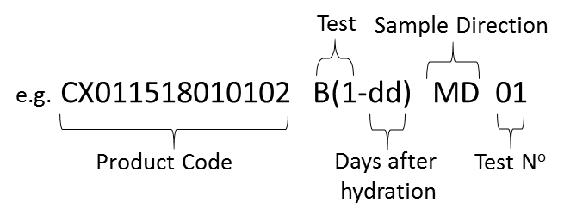

## Data Export

Once the test batch is complete, right click and select ‘export *raw* data to excel’ for ‘all samples’. Once done, rename columns using the guide above. Additionally, copy over no-PVC thickness and width for each sample, adding a new row for each. Once the compression tests are performed, these can be added to the same spreadsheet in another new row.

The file should be named ‘YYMMDD Bend Test’, each column labelled, and saved in *Lab RD > NEPR 2017-07 TESTING > Excel Data Point Export*

## Product Structure

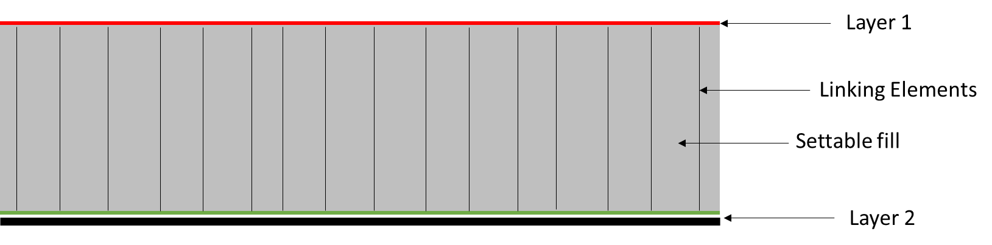

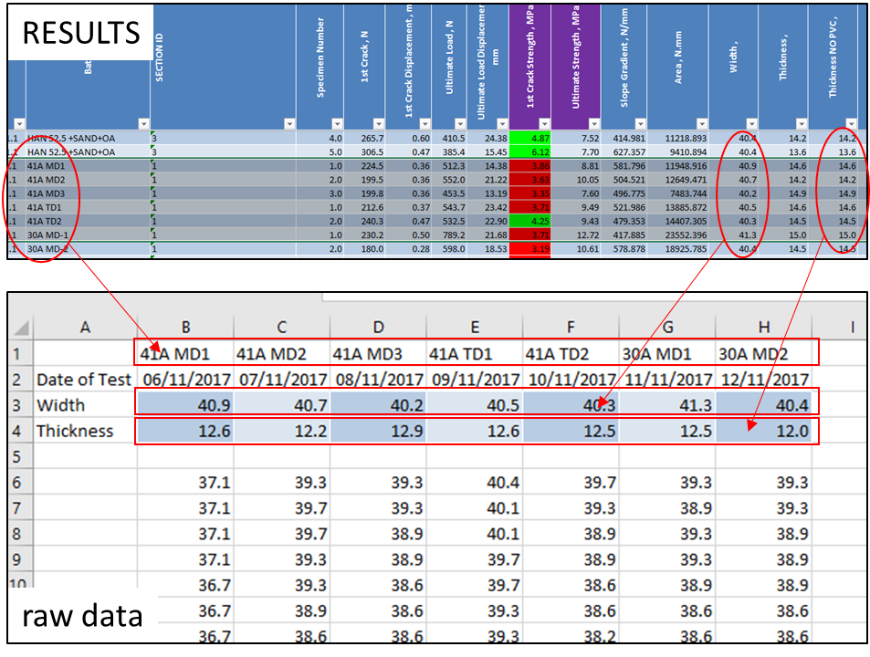

Bend Test Protocols

|  |  |
| --- | --- |
| B(1-dd) Test samples with Layer 2 under tension, with Layer 1 facing UP. |  |
| B(2-dd) Test samples with Layer 1 under tension, with Layer 1 facing DOWN. |  |